Manager’s Guide to Action Planning

Post Survey Steps

Now that the survey has taken place and the data is in, managers are responsible for action planning with their team. This is the most critical part of the employee survey process. Failure to plan and take action on the feedback provided by employees could negatively impact engagement levels and future survey results.
STEP ONE
Below are the recommended steps that have been identified as best practices to ensure success.

STEP THREE
STEP TWO
Create an action plan

- Identify one or two items or areas that the team can agree to focus on improving

TOOLS:
Action Planning in 1-2-3 p.11
Perceptyx Action Planning Tool p.11
Action Planning Template p.12
Review your team’s results

- Review your results
- Give yourself time to digest and reflect on your results
- Don’t act yet

TOOLS:
Reviewing your team’s results p.3
Manager’s Reactions to Feedback p.4 & 5
Self-Reflection Activity p.6

Share results with your team

- Have one or more discussions as a team to interpret the results

TOOLS:
What if I choose not to do anything? p.7
Debrief structure p.7
The 3 P’s p.8
Powerful Questions p.9
Debrief Derailers p.10

Reviewing Your Team’s Results
Each manager who receives results has access to the Perceptyx reporting site. This site contains:
- A summary report containing an overview of results which can be used to present results to your team
- On-demand reporting and data filtering allowing you to dive deeper into your results and gain greater insights into your team’s data
- Tools and resources to assist with understanding your results and developing your action plan

Back to home page

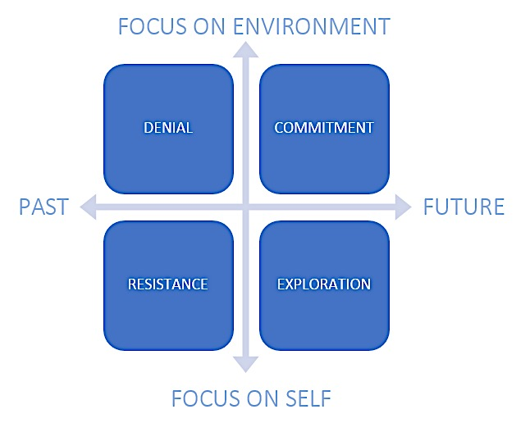
Manager’s Reactions to Feedback
Survey results create an opportunity for change. Even if a manager’s results are generally positive, there may be some surprises along the way, which can evoke a range of responses. How the manager responds to survey data can dictate how they interact with teams, and the actions they might choose to make.

The Change Grid describes the journey to action through four key responses outlined below. It is important to recognize that positive and negative responses to feedback are normal. The change grid helps demonstrate what these responses are, and describes key strategies to overcome any negative/counterproductive responses to the survey.

Back to home page
DENIAL | What is denial?  Denial can be based on a lack of understanding around the importance of the results. It takes the form of either underestimating the relevance of the data, or refusing to believe the data will lead to anything useful. When people are in avoidance they ignore the results; and may not communicate information with the wider team, or create meaningful action plans. | How do you recognize denial?  An individual, a group, or even a whole organization can exhibit symptoms of denial. A team exhibits denial, for instance, when it fails to see and address issues even when they are pointed out. | People say things such as:  “These surveys are a waste of time and resources”  “That’s ridiculous, they’ve never told me that before”  “This was just a tick the box exercise anyway”  “These results are not directly to do with me: it’s the organization’s issue” | How can you help leaders through denial?  - Share your observations about where they are at, and share that it is a normal reaction  - Encourage them to talk through how they are feeling  - Share information on survey program, what is expected of them, and how you can support them
RESISTANCE | What is resistance?  Resistance occurs when people may start to see the value of the survey process, but also directly experience the self-doubt, anger, anxiety, fear and uncertainty that forces them outside their comfortable established patterns to take the time to review, communicate and action plan. The resultant insecurity is a normal response that leads people to resist acting upon data. | How do you recognize resistance?  Resistance can take many forms. Active resistance may be demonstrated through criticism, grumbling and arguing. Passive resistance may see individuals quietly digging their heels in. Resistance can also be overt or can go underground where it often goes unrecognized until it boils over. People also tend to focus on the perceived negatives; what they will lose if they decide to acknowledge the results and work with their team. | People say things such as:  “I suppose I just have to take these results on the chin”  “I don’t have time for this. It’ll never work in this environment”  “I can’t make a difference – you don’t know the challenges I am faced with” | How can you help leaders through resistance?  - Share information on how the insights will help them meet business priorities  - Listen to the leader’s concerns, showing support and act as a sounding board  - Offer different ways of looking at things based on the leader’s objections/resistance  - Help the leader identify what things are in their control and influence; and what things are out of their control.
EXPLORATION | What is exploration?  The exploration phase is a time of possibilities and adaptation. People begin to open up to the survey data and seek to understand what can be done about it. They figure out how to make the actions work for them. Energy and enthusiasm are up, and leaders are responsive to support and suggestions to improve results. | What does exploration look like?  Leaders and teams work together more cooperatively and have a renewed interest in how to make the organization a better place to work. This results in increased creativity and a more positive energy. | People say things such as:  “This could work”  “Let’s get together and work out how we can...”  “How can I make this work for me?”  “Maybe we could try…”  “This means I’ll have the chance to…”  “I think I understand now…” | How can you help leaders through exploration?  - Help leaders look at the possible opportunities  - Share best approaches to challenges in different areas  - Help leaders explore the pros, cons and potential challenges in approaches for moving forward  - Encourage them to link in with other managers and leaders to promote action  Back to home page
COMMITMENT | What is commitment?  In commitment, leaders have aligned themselves with the survey process and are committed to making themselves, their team, and the organization successful. They view the survey project positively and see many advantages for driving the agenda forward. Leaders hold themselves accountable for results. They understand the importance of the results and look forward to applying the lessons learned to future challenges. | How do you recognize commitment?  In commitment, people engage in their work with high levels of energy and enthusiasm. They commit to action and provide regular opportunities for follow up. They may volunteer to do something they have never done before.  They understand the change process that they have just been through and look forward to applying the lessons learned to future changes. | People say things such as:  “I have learned a lot during this process”  “This really works much better now”  “I hope the others catch on soon” | How can you help leaders sustain commitment?  - Educate leaders about the purpose of the different tools to foster action  - Encourage leaders to focus their energy and time on where they can make the biggest difference  - Create opportunities for discussion around further changes on the horizon  - Emphasize the importance of communication – at least three times during the year

Back to home page

Self-reflection activity: Your business context
Prior to analyzing survey results, it is important to be able to do so in the context of the challenges and opportunities for your group. This section provides some questions which can be used to better understand the context behind your team’s survey responses.

What are your business priorities?
- What are your current business goals?
- What are the key metrics that you use to gauge strategic success?
- What is the biggest challenge you are currently facing?
  - What do you see as potential solutions to this challenge?
  - What barriers do you see getting in the way of that solution?
  - What has kept these barriers from getting removed?
- What are your strengths as a department/division?
- What does the department/division need to get better at fast?
- What is your long-term vision for your organization?
  - Where are you at risk?
  - What is the distance between where we are now and where we want to be?
  - What must change for you to achieve your outcomes?
- How are people important for you to achieve your business priorities?
  - What are you most interested in understanding from the survey?
  - What key groups are important to explore?

Back to home page

The Team Debrief
Once the manager has reviewed the results, it is time to share with the team.

Best practices for sharing team-level results:
- Ensure that all data is shared with all team members
- Don’t try to figure out who said what
- Ensure all team members have the opportunity to be engaged in the result and the action planning process
- Consider sharing data in advance of the team debrief; allow them to debrief independently first
- Inform your team that you are sharing the data with them and look forward to having open discussions with them
- Schedule the team debrief for soon after you share the data

What if I choose not to do anything with the survey?
Ignoring the survey results may have serious long-term effects on employee perceptions of trust and openness within the company. If employees do not receive feedback from the survey they may consider:
- Is the survey being taken seriously or was it just a formality?
- Why bother filling it out next time if the information doesn’t go anywhere?
- Does my manager really care about my opinion?
- Am I being kept out of the loop? Were the results really that bad?

Structuring the debrief
Below is a structure that leaders can adapt for communicating to the workgroup:
- Revisit the survey process
- Remind your staff why the organization has conducted the survey
- Briefly explain how the survey was conducted
- Refresh your staff’s knowledge about the importance of the survey project
Outline the key results
- Make it clear that you accept the results and intend to use them to improve
- Detail what results are being presented to staff
- Convey what you have learned from the survey data (strengths and opportunities)
- Indicate the areas which could be potential areas of focus
- Let staff know that you will be seeking their feedback on results to strengthen your understanding
- Discuss the next steps with your workgroup
Back to home page

The Three P’s: Participation, Perspective and Process
P
The following diagram details some of the key principles to keep in mind during the team debrief:

PARTICIPATION
Seek the team’s input around the results, ask questions and collaboratively create action plans. Your questions make a difference; see Powerful Questions on the next page for some tips.

P
P

PROCESS
The process described above should also create a safe environment for sharing thoughts. Employees should feel that their confidentiality is preserved.

PERSPECTIVE
Perspective is about sharing your own views on the data and offering a proposed approach on the plan moving forward.

Back to home page
Back to home page

Powerful Questions
The following section summarizes a range of questions that can be leveraged to generate dialogue during the debrief.

Questions for focusing attention
- What’s important to you about the results and why do you care?
- What opportunities can you see in_________?
- What do we know so far/still need to learn about _________?
- What assumptions do we need to test or challenge here in thinking about _________?

Questions for getting deeper insight and clarity
- What’s taking shape? What are you hearing underneath the variety of opinions being expressed?
- What’s emerging here for you? What new connections are you making?
- What’s missing from this picture so far? What is it we’re not seeing? What do we need more clarity about?
- If there was one thing that hasn’t yet been said to reach a deeper level of understanding/clarity, what would that be?

Questions that create movement towards action
- What would it take to create change on this issue?
- What could happen that would enable us to feel fully engaged and energized about _________?
- What’s possible here and who cares? (rather than “What’s wrong here and who’s responsible?”)
- What needs our immediate attention going forward?
- If our success was completely guaranteed, what bold steps might we choose?
- How can we support each other in taking the next steps? What unique contribution can we each make?
- What challenges might come our way and how might we meet them?

What questions will you ask?

Back to home page

Debrief Derailers

Confidentiality vs. Anonymity
In some instances, it may be beneficial to address the topic of confidentiality vs anonymity. The following section provides a definition of each type that you can use in your discussions.

The important thing to reinforce is managers can only see aggregated results. No manager can see responses from any individual in isolation.

Confidential Survey
A confidential survey is a survey where each employee receives a unique URL or identifying code, which ties specific demographic data to that employee when they take the survey. Each employee’s identity and responses remain confidential because reporting is always aggregated, meaning that no individual employee’s responses or identity will be displayed to anyone with access to results. This means that a manager won’t be able to single someone out and know what they said on the survey.

Anonymous Survey
An anonymous survey is a survey that is sent to employees with a general URL used by everyone taking the survey. During an anonymous survey, there is no identifying information about employees such as gender, ethnicity, tenure, location, and other demographics or performance related data that is tied directly to each employee before an employee takes the survey. The only employee related data that can be provided is information that the employee elects to provide at his/her own discretion while taking the survey. These types of questions are called “demographic questions” and have the benefit of providing a choice to employees for whether they want to provide the information or not.

We Can’t Solve the World’s Problems
In some circumstances, groups can display a sense of “helplessness” and may engage in finger pointing towards other departments, or even characterize the issues they are faced with as being outside of their control.

When we take a systemic view of an organization, there are always things we can do, and things that are outside of our control. It is important to remind groups to focus on those actionable activities that they can put in place that are within their control.
I can control directly
Outside my
control
I can control
indirectly
“Do not let what you cannot do interfere with what
you can do.”
-JOHN WOODEN

Back to home page

Action Planning in 1-2-3
1.
Identify a focus area – select and prioritize your team results.

2.
Select two actions for improvement.

3.
Talk about it, keep it visible and make adjustments when needed.

It is recommended that managers take advantage of the easy-to-use action planning tool within the Perceptyx reporting site. Capturing your action plan will help to ensure that action is taken and progress is made toward your areas of focus.

Action Planning Portal

Action planning inside of the Perceptyx reporting site is a breeze! Follow these steps:

- Log into the Perceptyx reporting site | See URL and login detail provided via email
- Select Favorability Report
- Click the pencil icon to the left of the item on which you and your team would like to take action on
- Click on the icon to view Actionable Insights
- Move across to the Start/Edit Action Plan tab  - Enter 2 things that your team will do to improve in this area (use the suggestions button for action step ideas)  - Enter the 3 dates that your team has agreed upon to discuss or follow-up on your action plan | 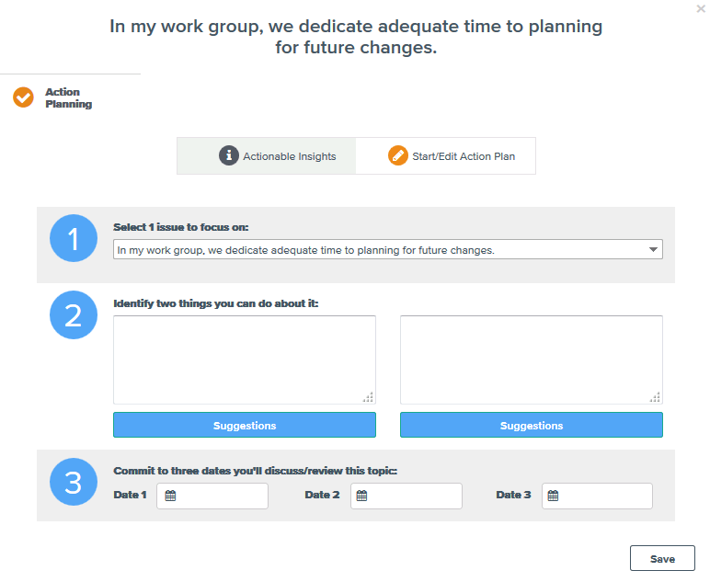
- Save your action plan
Note that the icon at the bottom right of each report will provide you with helpful hints on navigating the site and using the functionality available.
Back to home page

Action planning Template Example
Below is a paper version of the electronic template found in the Perceptyx reporting site. Whenever possible, please use the online tool to create and store your action plans.

 | Select 1 issue to focus on:
 | Identify two things you can do about it:
 | Commit to three dates you'll discuss/review this topic:
 | Date 1: | Click or tap to enter a date. | Date 2: |  | Click or tap to enter a date. |  | Date 3: | Click or tap to enter a date.
Back to home page

